Algebra 2 with Trigonometry
In Class Group Project

In small cooperative learning groups (2 students), your task is to use http://www.desmos.com to creatively and neatly design your own picture!
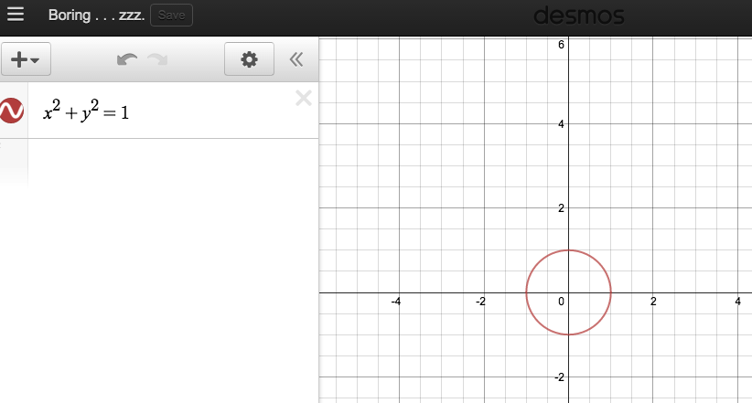
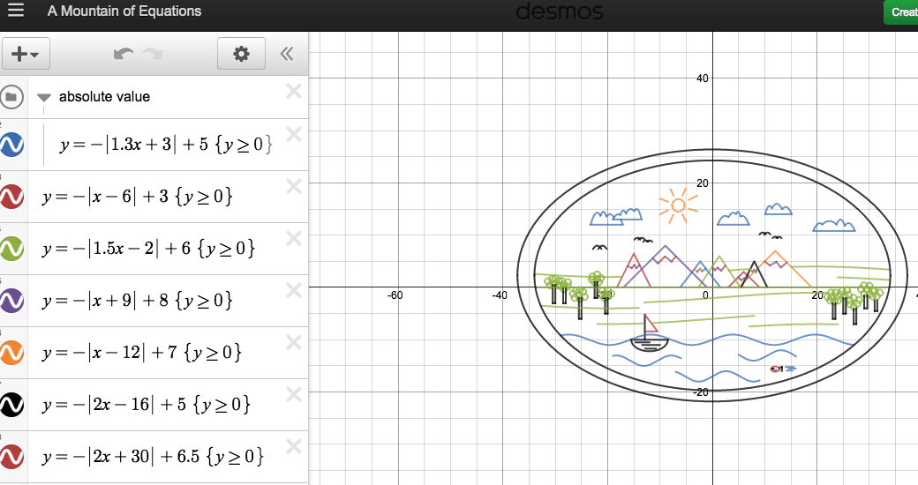
Turn this… Into this!!!
To complete the following, you must utilize the families of functions we have learned in this course:

Linear: 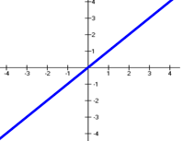 Quadratic: 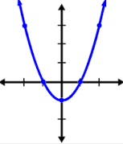 Exponential Growth/Decay: 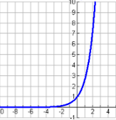 Rational: 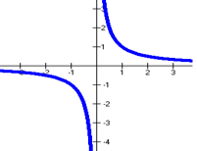
$f\left(x\right)=mx+b$ $f\left(x\right)=ax^{2}+bx+c$ $f\left(x\right)=a{\left(1±r\right)}^{x}$ $f\left(x\right)=\frac{a}{x} f\left(x\right)=\frac{a}{x-h}+k$
$f\left(x\right)=a{\left(x-h\right)}^{2}+k$ $f\left(x\right)=ae^{x-h}+k$ $f\left(x\right)=\frac{ax+b}{cx+d}$ $f\left(x\right)=\frac{ax^{2}+bx+c}{dx^{2}+fx+g}$

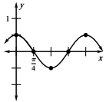
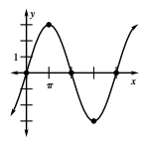
Absolute Value: 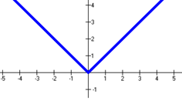 Cubic: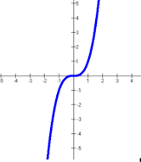 Logarithmic: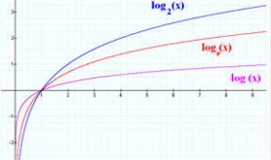 Trigonometric:
$f\left(x\right)=a|x-h|+k$ $f\left(x\right)=ax^{3}+bx^{2}+cx+d$ $f\left(x\right)=a\log_{10}\left(x-h\right)+k$ $f\left(x\right)=a\sin{bx}$
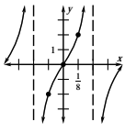
$f\left(x\right)=a\cos{bx}$
$f\left(x\right)=a\tan{bx}$
Radical: 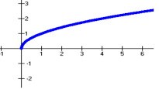 Circles: 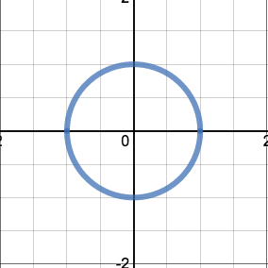 Ellipses: Hyperbolas:
$f\left(x\right)=a\sqrt[n]{x-h}+k$ ${(x-h)}^{2}+{(y-k)}^{2}=r^{2}$ $\frac{{(x-h)}^{2}}{a^{2}}+\frac{{(y-k)}^{2}}{b^{2}}=1 \frac{{(x-h)}^{2}}{a^{2}}-\frac{{(y-k)}^{2}}{b^{2}}=1$
****By the way . . . Did you know that you could color in your picture? (Hint: Inequalities and shading
$<, ≤, >, ≥$)****
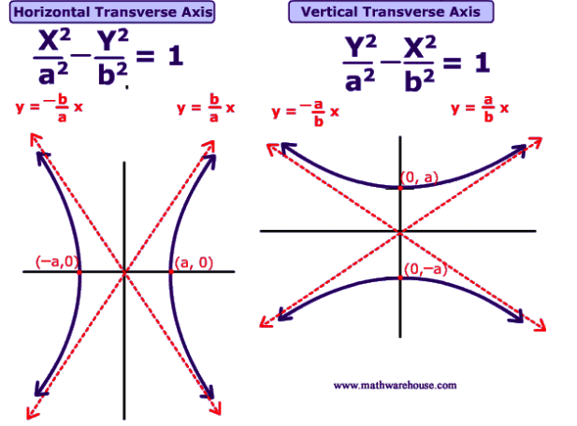
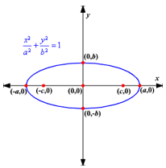
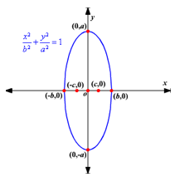
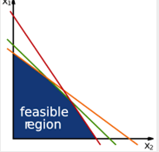
$\frac{{(y-k)}^{2}}{a^{2}}-\frac{{(x-h)}^{2}}{b^{2}}=1$
Directions:
STEP 1: Create a Desmos account (everyone needs an account but only one person needs to submit this portion of the project)
You can either sign in with your HPS Google Account or under your own e-mail address and password. You each need an account so you can save and share your work.

STEP 2: Create a detailed picture with all of the functions outlined above. Organize your work NEATLY by the different functions in SEPARATE folders.

STEP 3: When you’re done, get the link to your work. This can be done with the share button in the top right corner of the website, if you’re logged in. Paste the link into the form on coughlinhhs.weebly.com.

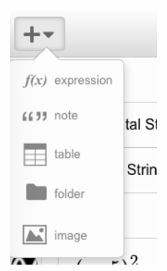
Some quick how-tos:
How do I turn graphs on and off?
Click the graph icon to turn graphs on or off.
Note that if you click and hold a graph icon, it will give you color, transparency, and style options. 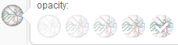

How do I make my lines thicker?
Click on the tool on the top right and select “Projector Mode”

How do I create domain restrictions?
After typing in the equation for the graph, put in brackets { } and write a compound inequality.
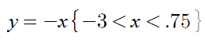

How do I make folders to group the functions?
Press the big + sign in the top left corner below the black bar. You’ll get a menu like the one above. “Folder” is the fourth option. You can then drag your equations into folders.
How do I change colors?
Click the gear icon at the top of the equations list:
From there, if you click on a graph icon it will give both color and style options:

How do I have Desmos find the line of fit for me?
Type in the kind of function you are trying to create. For example, type in $f\left(x\right)=a{\left(x-h\right)}^{2}+k$ and when it says click on “all” and in another line type $(h,k)$ to create a vertex point that you can drag.

How do I share this project with people in my group?
Click on the icon and send an email directly to the person or copy the link into an email.

This Project is DUE: _____________________________________________

Names:____________________________________________________________________________________________________

RUBRIC

Functions: | How many do we need? | How many do we have? | Were we neat? | Were we creative?
Linear | 3 |  | Do our functions meet nicely?  Did we include any shading? | Is our picture detailed?  Did we do something other than a house?
Quadratic | 3
Exponential | 3
Rational | 3
Absolute Value | 3
Cubic | 3
Trigonometric | 3
Radical | 3
Circles | 3
Ellipses | 3
Hyperbolas | 3

TOTAL:_______________

Names:____________________________________________________________________________________________________

RUBRIC

Functions: | How many do we need? | How many do we have? | Were we neat? | Were we creative?
Linear | 3 |  | Do our functions meet nicely?  Did we include any shading? | Is our picture detailed?  Did we do something other than a house?
Quadratic | 3
Exponential | 3
Rational | 3
Absolute Value | 3
Cubic | 3
Trigonometric | 3
Radical | 3
Circles | 3
Ellipses | 3
Hyperbolas | 3

TOTAL:_______________

